The Old Testament
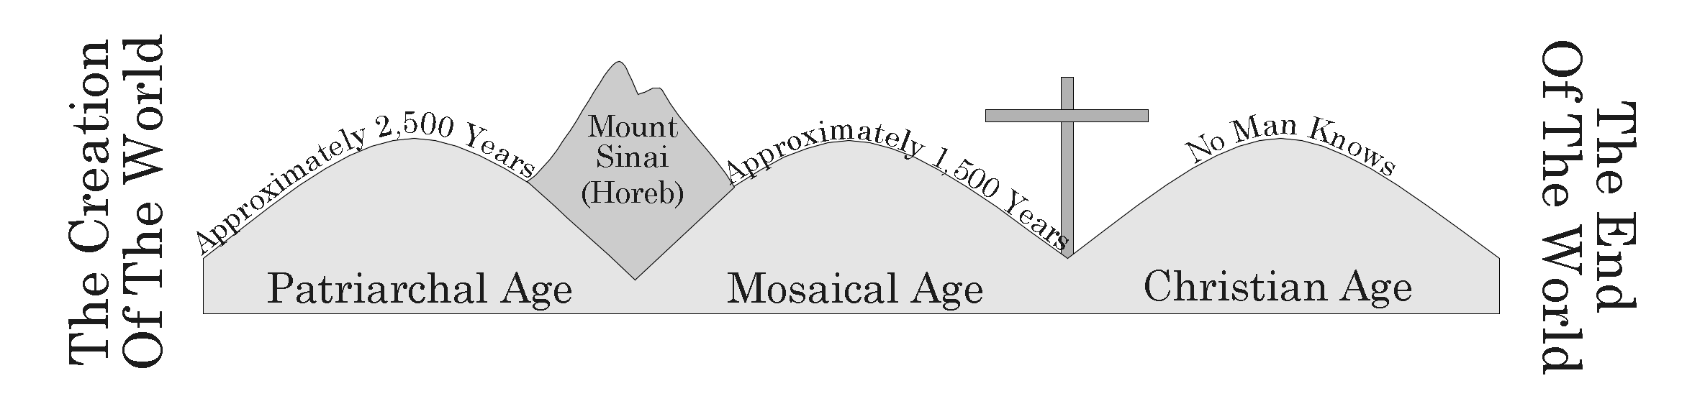

- The Fall Of Man
- God Gave Adam And Eve A Law Genesis 2:15-17
B. Adam And Eve Sinned Genesis 3:1-7
C. The Definition Of Sin 1 John 3:4
D. The Result Of Sin Romans 5:12, Isaiah 59:1-2

- Noah And The Flood
  - God Sent A Flood To Destroy All Men Who Were Evil Genesis 6:5-8, 13-22
  - What Saved Noah:
    - Grace Genesis 6:8
    - Faith Hebrews 11:7
    - Obedience Hebrews 11:7
    - Water I Peter 3:20

- The Promises To Abraham
  - Abraham Was Faithful To God, And Given Three Promises Genesis 12:1-3, 13:15
      - Land, Nation, and Spiritual Blessing
      - The Spiritual Blessing Was Fulfilled Through Christ Galatians 3:14-16

V. Bondage To Egypt And The Exodus
A. Jacob’s Family Entered Egypt And They Became Enslaved Exodus 1:5-14
D. Moses And The Burning Bush Exodus 2-3
E. The Ten Plagues Exodus 7-12
F. The Israelites Went Across The Red Sea And On To Sinai Exodus 14-19
G. Moses Was Given A Law For The People Including 10 Commandments Exodus 20, 24:12
H. A Lesson From The Old Testament:
1. God Rewards Those Who Keep His Commandments And Punishes Those Who Do Not Romans 11:22
i. Example of Nadab and Abihu Leviticus 10:1-3
I. Joshua Led The People Of Israel Into The Promised Land Acts 13:19

- Israel Is Ruled By Judges Then Kings
  - The Time Of Judges Acts 13:17-20
  - Saul And Then David Became King Over Israel; The Spiritual Promise Would Be His Descendant Acts 13:21-23
  - The Kingdom Was Divided Into Judah And Israel 1 Kings 12
    - Israel Was Taken Captive By Assyria Around 723 B.C. And Was Lost
2. Judah Was Taken Captive By Babylon Around 606 B.C.
  - Prophets Predicted The Coming Of The Messiah Isaiah 9:2-7
  - The Messenger In The Wilderness Would Come First Malachi 3:1

