The Coming Of The Messiah And His Good News
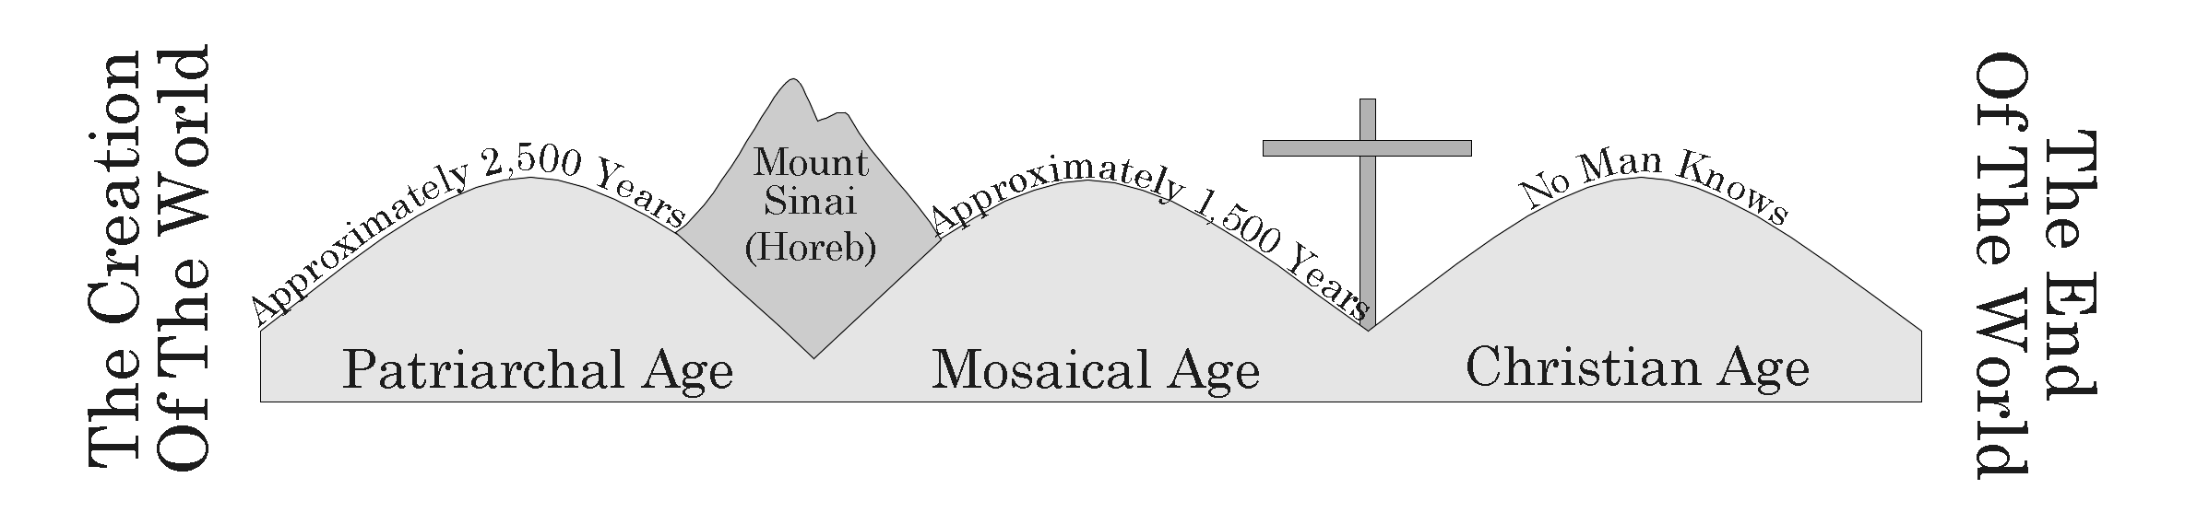

I. The Messiah Was Prophesied About
A. The Messenger In The Wilderness Isaiah 40:3, Matthew 3:1-3
B. Birthplace Micah 5:2, Matthew 2:1, 4-6
C. Born Of A Virgin Isaiah 7:14, Matthew 1:23-25

II. Jesus Christ, The Son Of God
- Miracles And Teachings Matthew 4:23
  - Some Of Christ’s Teachings
    - Corrected The Morals Of The Day (Matthew 4:23 - Matthew 7:29), Matthew 5:38-39
    - Salvation Was Soon To Come John 3:16
- Rejection, Death, Burial, Resurrection, And Ascension Matthew 27:1-2, 16-26, 50, Luke 23:44-46, John 19:31-34, 38-42 Matthew 28:1-7, Acts 1:9-11

III. Christ Took Away The Old Law
A. Christ Did Away With The Old Law, Established A New One Which We Follow Today Hebrews 10:9, Hebrews 9:11-17
B. As Part Of The New Law, God Has Commanded Everyone To Repent Of Their Sins Acts 17:30

V. The Problem Of Sin And The Solution Of Grace
A. Sin Is A Transgression Of God’s Law 1 John 3:4
B. All Have Sinned And Any Sin Will Be Punished By Spiritual Death Romans 6:23
C. We Can Be Saved From Our Sins By Grace Ephesians 2:8

VI. How Do We Obtain God’s Grace?
- The Gospel Is Christ’s Good News, Salvation 1 Corinthians 15:1-4
- Christ Saved Us From Our Sins By Making An Atonement For Them (Hebrews 9:11-14)
- We Must Obey The Gospel 2 Thessalonians 1:7-8
- Steps We Must Take:
  - Believe In Christ John 3:16
  - Repent Of Your Sins Acts 3:19
  - Confess Your Belief In Christ Romans 10:10
  - Be Baptized Into Christ For The Remission Of Your Sins Acts 2:38, Acts 22:16
    - Obey A Form Of The Gospel- Christ’s Death, Burial, and Resurrection Romans 6:3-11, 17

VII. New Testament Examples
A. Saul Of Tarsus Acts 9:1-12, Acts 22:11-16
B. The Ethiopian Eunuch Acts 8:26-40

VIII. Those Who Obey Are Added To Christ’s Church
A. The Obedient Become Children Of God Acts 2:38, 47, Romans 8:16-17

