The Coming Of The Messiah
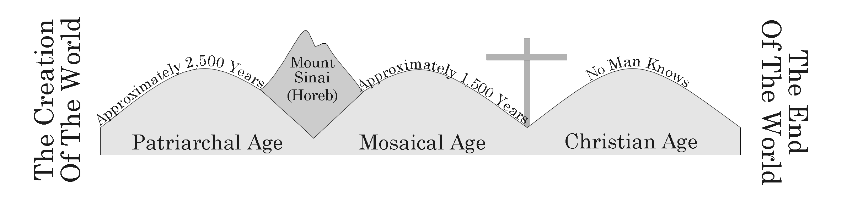

I. Messiah Prophesied About
A. The Messenger In The Wilderness Isaiah 40:3, Matthew 3:1-3
B. Birthplace Micah 5:2, Matthew 2:1, 4-6
C. Born Of A Virgin Isaiah 7:14, Matthew 1:23-25

II. Who Was Jesus?
A. King Revelation 1:5
B. Teacher Matthew 4:23
C. Savior John 3:16-17
D. Son Of God Matthew 16:13-17

III. Christ’s Life Before Age 30
A. Laid In A Manger After Birth Luke 2:7
B. Encounter In Jerusalem At Age 12 Luke 2:41-51
C. Grew Strong And Prospered In Wisdom Luke 2:52

IV. Christ’s Life From About Age 30
- Baptism And Temptation Matthew 3:1-6, 13-17, 4:1-11, 1 John 2:16
- Miracles And Teachings Matthew 4:23
  - Christ’s Teachings
    - Corrected The Morals Of The Day Matthew 4:23 - Matthew 7:29, Matthew 5:38-39
    - Salvation Was Soon To Come John 3:16
    - Christ’s Spiritual Kingdom Was Soon To Come Matthew 16:28
- Rejection And Death Matthew 27:1-26, Luke 23:44-46
- Burial, Resurrection, And Ascension John 19:31-34, 38-42, Matthew 28:1-7, Acts 1:9-11

V. Christ Took Away The Old Law
A. The Israelites Were To Obey The Old Law Exodus 19:3-8
B. At That Time, God Judged All Others By Their Conscience Acts 17:29-30
C. The Israelites Broke Their Covenant With God Hebrews 8:8-9
D. Christ Did Away With The Old Law, Established A New One Hebrews 10:9

VI. Salvation Promised
A. Obtained Through The Gospel Romans 1:16

