The Mosaical Dispensation
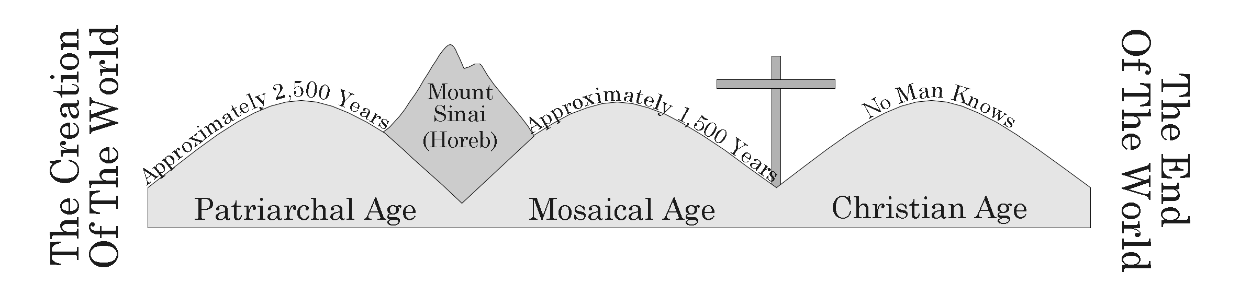

I. A Lesson To Be Learned
A. The Old Testament Was Written For Our Learning Romans 15:4
B. One Lesson Is God’s Goodness And Severity Romans 11:22

II. Israel Camped At Sinai
A. Arrival At Sinai Exodus 19:1-2
B. The Ten Commandments Were Given Exodus 20:1-17
C. The Tabernacle Was Built Exodus 25-40
D. Nadab And Abihu Leviticus 10:1-3
E. The People Were Numbered Numbers 1:45-47

III. The Conquest Of Canaan
A. Spies Were Sent Into Canaan And Israel Was Disobedient Except Joshua And Caleb Numbers 13-14, Matthew 7:13-14
B. Wandering In Desert Numbers 14:29-35
C. Joshua Led Israel Across The Jordan River And Into Canaan Joshua 1-3

IV. The Time Of Judges
A. Israel Was Ruled By Judges Acts 13:17-20

V. The Time Of Kings
A. Israel Demanded A King 1 Samuel 8:1-9
B. Saul Was Made King And Was Rejected 1 Samuel 15:1-28
C. David Was Made King 2 Samuel 5:1-3, Acts 13:21-23
D. The Kingdom Was Divided 1 Kings 12
1. The Northern 10 Tribes Of Israel
2. The Southern 2 Tribes Of Judah
E. The Young Prophet 1 Kings 13:1-24
F. Naaman 2 Kings 5:1-14
G. Both Kingdoms Were Taken Captive
1. Israel Was Taken Captive By Assyria Around 723 B.C. And Was Lost
2. Judah Was Taken Captive By Babylon Around 606 B.C.

VI. The Coming Messiah
A. A Kingdom Was To Come Daniel 2:31-43
B. A Messiah Was To Come Isaiah 9:2-7
C. He Was To Come At The Time Of The Roman Empire Daniel 2:44-45
D. God’s Messenger Would Prepare The Way Malachi 3:1, Matthew 3:1-3

